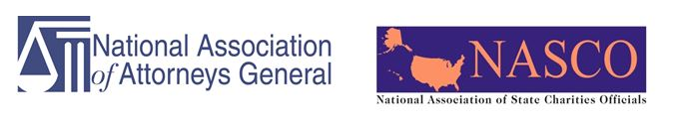
2019 NAAG/NASCO ANNUAL CONFERENCE
Nashville, Tennessee
STEPPING OUT TO THE WORLD
OPEN SESSION AFTERNOON – Thursday, October 17, 2019

12:15 – 1:00 | Bring your own lunch – informal with Regulators
1:00 – 1:30 | Welcome with attending Attorneys General
1:30 – 3:00 | Regulation Outside Our Borders: Challenges, Successes and Coordination in Regulation of Charities – Views from our Counterparts in Australia, Canada and Singapore  Karin Kunstler Goldman (Assistant Attorney General NY) – Introduction  David Mulvihill (Vice President and General Counsel) – Make-a-Wish - Moderator  Dr. Hak Seng Ang (Commissioner of Charities; Ministry for Culture, Community and Youth; Singapore)  Paulette A. Kirkland (Director Jamaica Department of Co-operatives and Friendly Societies)  Sallyann Stonier, Director of Registration, Australian Charities and Not-for-profits Commission - Australia
3:00 – 3:30 | Networking Break
3:30 – 4:30 | CROWDFUNDING ISSUES:  Rob Wexler (Attorney Adler & Colvin), Moderator  Sara Hall, Chief Legal Officer & General Counsel, St. Jude Children’s Research Hospital  Thomas Donovan, Director Charitable Trusts, New Hampshire, NASCO crowdfunding working group chair  Kim Wilford, General Counsel, GoFundMe
4:30 – 5:30 | Restatement on Charities –  Jill Horwitz, Professor UCLA; overall chairwoman of the ALI committee  Karin Kunstler-Goldman (Assistant Attorney General NY);  Mark Pacella (Chief Deputy Attorney General PA);
6:30 | NASCO reception

2019 NAAG/NASCO ANNUAL CONFERENCE
Nashville, Tennessee
STEPPING OUT TO THE WORLD
OPEN SESSION DAY 2 – Friday, October 18, 2019

8:00 – 8:30 | Continental Breakfast
8:30 – 10:00 | State Roundtable  Cindy Lott, Professor Columbia University, Moderator  States to be announced
10:00 – 10:15 | Break
10:15 – 11:15 | DISASTER RESPONSE ISSUES –  Regine Webster, VP at Center for Disaster Philanthropy  Tim Delaney of Council for Nonprofits  State regulators to be announced
11:15 – 12:15 | Ethics – Cyber security –  Scott E. Augenbaum  Former FBI Agent  Author & Consultant  Scotteaugenbaum.com Consulting  Matthew Dunn  Former FBI Agent  Associate Managing Director, Cyber Risk  Kroll, a division of Duff & Phelps
12:15 – 1:30 | Lunch session

